## Brief Summary

This document is used to describe a new requirement and the new function Raise Error.

New device audit status:

Unverified - Error

New audit status:

Incomplete - Error

Related Issue

28 - [MAM] Work order is completed during a validation in Manual Audit

## Validate Operational Moving Device

When a user validates a device (Life Cycle: Operational Moving) in a manual audit, the related work order will be updated if there is a work order created for this device.

Per the new requirement, no work order should be updated in any manual audit. Which means when a user validates a device (Life Cycle: Operational Moving) in a manual audit, the work order should not be updated automatically.

## Raise Error

There will be a button Raise Error next to the Validate button in the reserved device detail panel

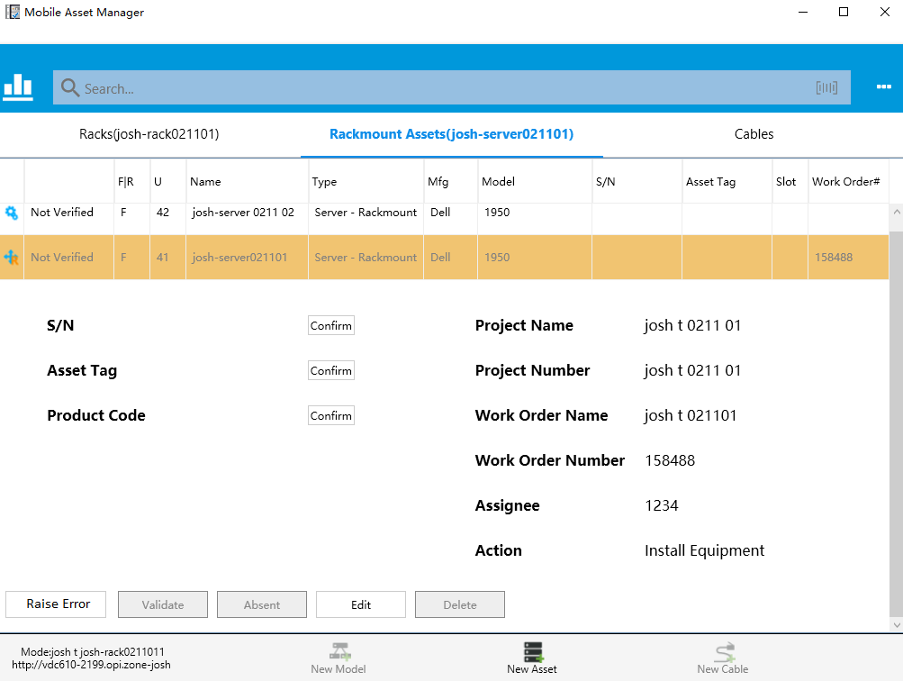

## Unverified - Error

Unverified - Error is a new device audit status. Now all device audit status are

* Not Verified
* Verified
* Verified - New
* Verified - Error
* Absent
* Unverified - Error

After the user clicks the Raise Error button, the user needs to confirm raise error.

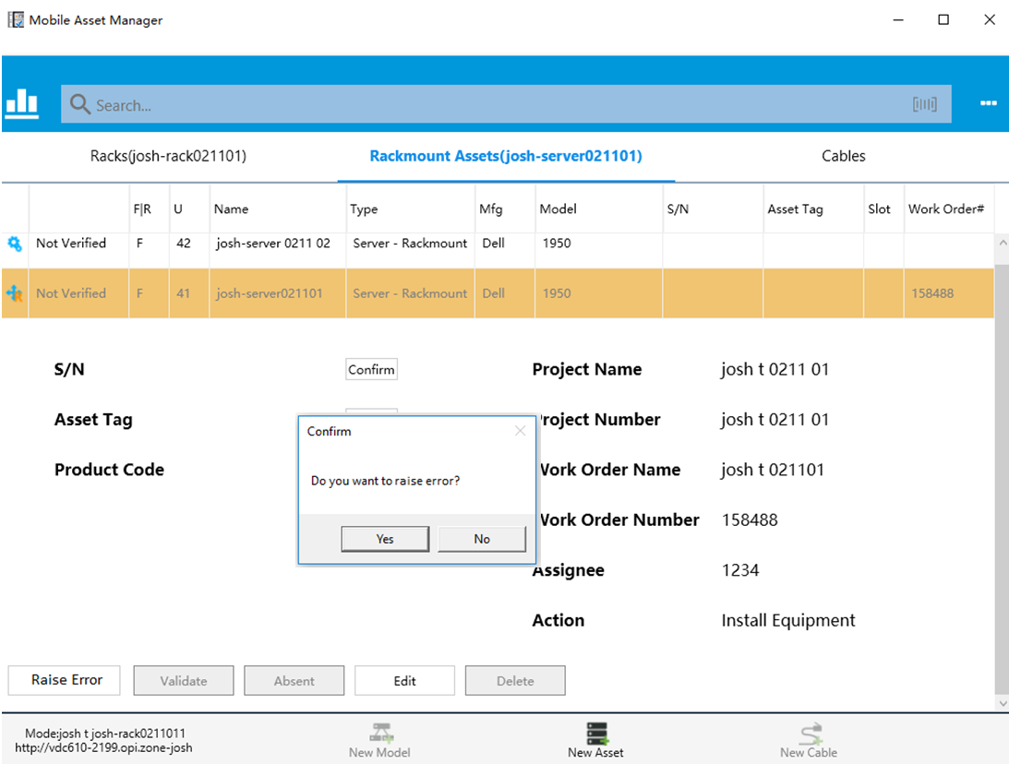

After the user confirmed, the reserved device will have the status of Unverified - Error.

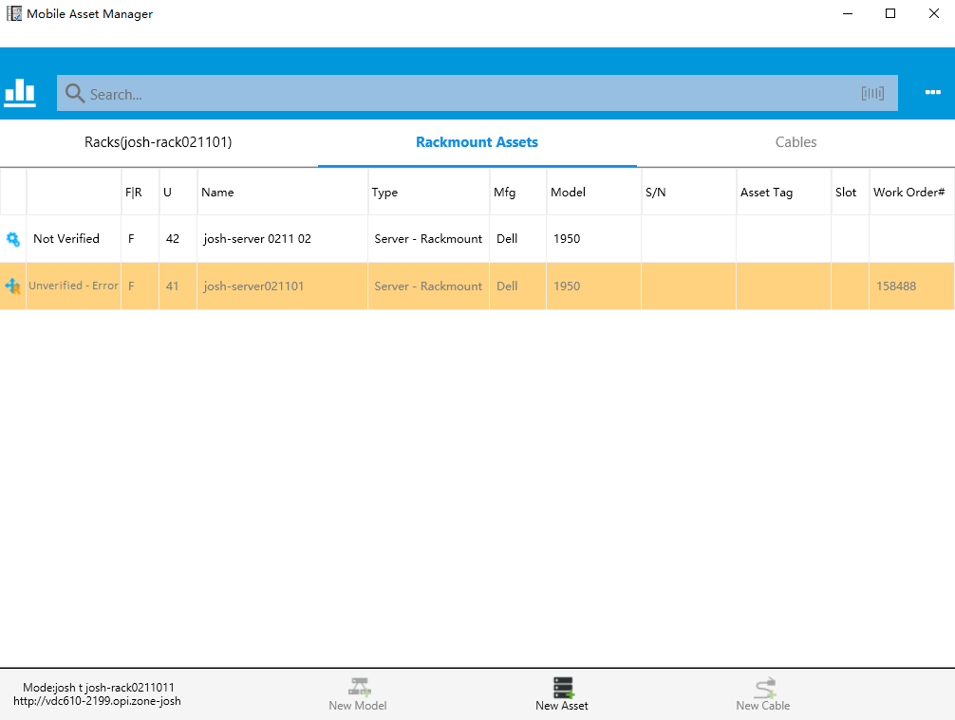

NOTE

*In the mock up above, the device audit status is updated of the reserved device (Life Cycle: Reserved Available/Reserved Procurement/Reserved Move).*

*Currently reserved device will not be listed in the search list in the VDC system like the following one. This is because reserved devices are not real devices. Thus this reserved device with Unverified - Error only exists in the device list in MAM*

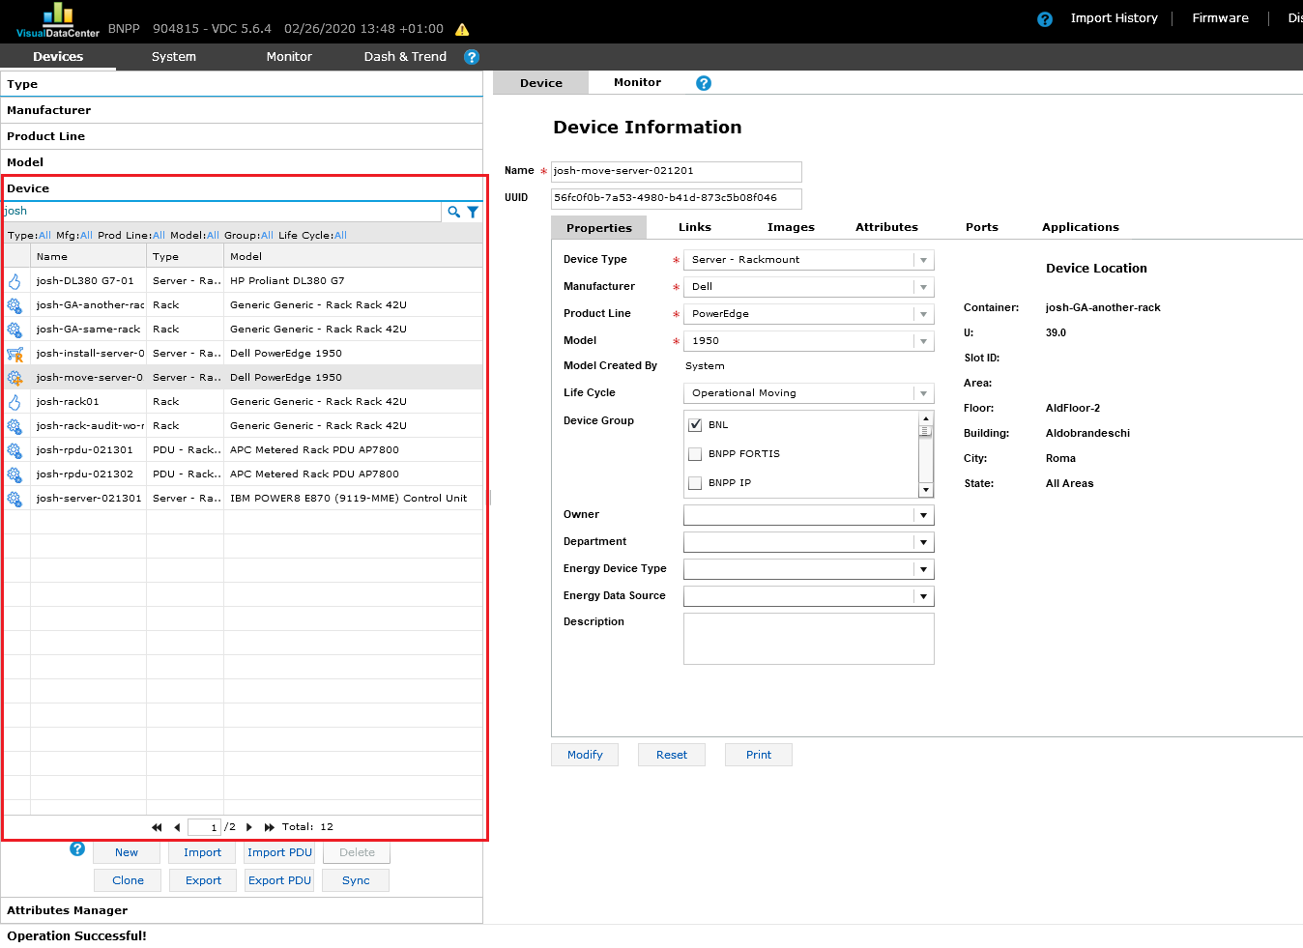

## Validate Rack

When the user clicks the Validate button on the rack, MAM will check all devices in the rack. If there is a device with status Unverified - Error, the rack will have the status Unverified - Error.

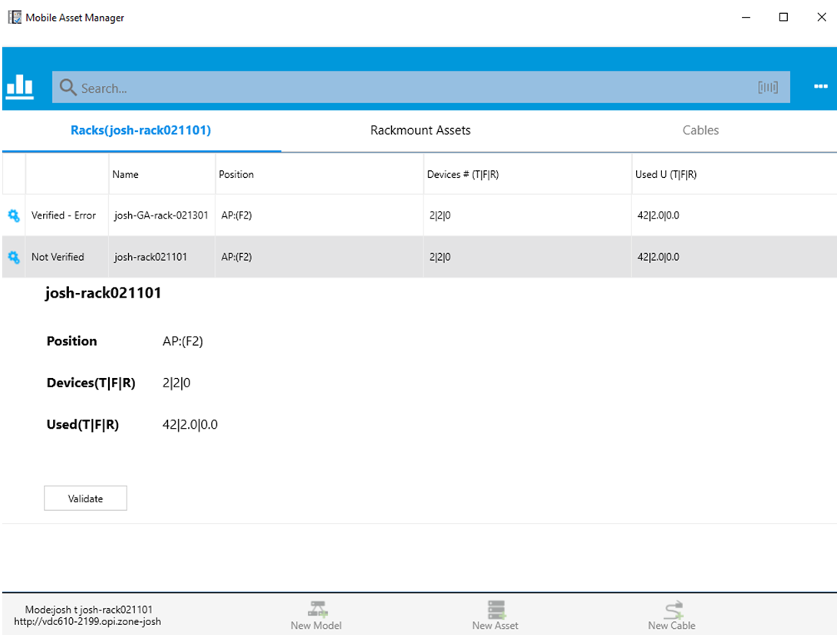

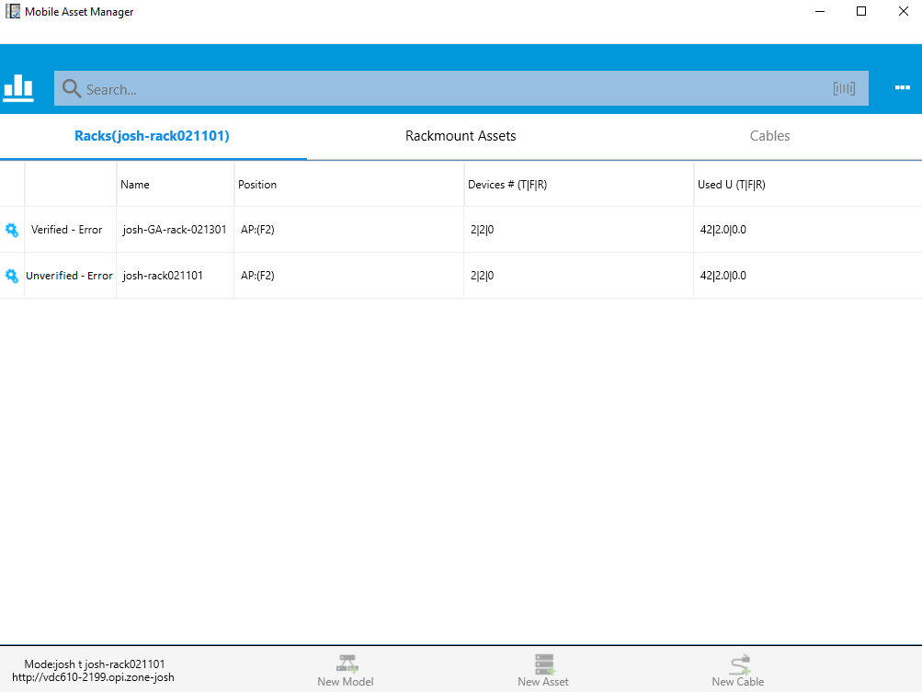

## Incomplete - Error

Incomplete - Error is a new audit status. All audit status are

* Not Started
* In Progress
* Completed
* Completed With Error
* Incomplete - Error

When all racks are Verified/Verified - Error/Unverified - Error, the audit status will be updated. Conditions are listed in the order from high priority to low priority. Processing is in this order and it stops after the condition is met.

* If there is a rack with status Unverified - Error, the audit will get status Incomplete - Error.
* If there is a rack with status Verified - Error, the audit will get status Completed - Error.
* If all racks are with status Verified, the audit will get status Completed.

Incomplete - Error is an end state. Audits with status Incomplete - Error will not be listed in the audit list in MAM.

